**Upload to CWB FileReceiver Process via API**

Data can be automatically uploaded via API to CWB FileReceiver (<https://filereceiver.cwb.gov.tw/api/file>).

The attachment files are example of curl and python program.

We will provide ACCOUNT, API token and VDIR for you.

Please provide the sample products, including types and naming rules.

For example: **NCUwindprof_202006031300_60_INT.png**

This is NCU wind profiler data, it is a PNG file.

The file name rule is “NCUwindprof_YYYYMMDDHHmm_60_INT.png”

The "60" is the data time interval in minutes, and INT is the display mode.

Example of curl program

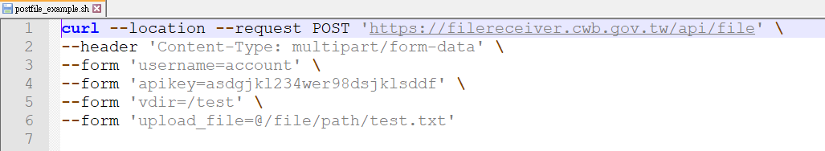

Example of python program

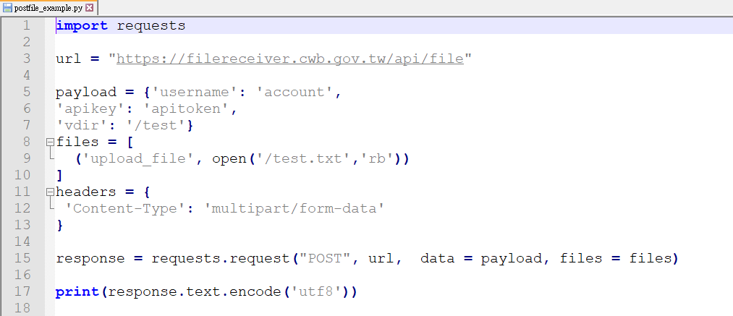

Example of NCU wind profiler data